General Welfare Requirement: Safeguarding and Promoting Children's Welfare
The provider must take necessary steps to safeguard and promote the welfare of children

Gorran Pre School
Safeguarding children
1.1 Children's rights and entitlements
Policy statement
Gorran Pre-School Hoglets promotes children's right to be strong, resilient and listened to by creating an environment in our setting that encourages children to develop a positive self image, which includes their heritage arising from their colour and ethnicity, their languages spoken at home, their religious beliefs, cultural traditions and home background.
Gorran Pre-School Hoglets promotes children's right to be strong, resilient and listened to by encouraging children to develop a sense of autonomy and independence.
- Gorran Pre-School Hoglets promotes children's right to be strong, resilient and listened to by enabling children to have the self-confidence and the vocabulary to resist inappropriate approaches.
- Gorran Pre-School Hoglets helps children to establish and sustain satisfying relationships within their families, with peers, and with other adults.
Gorran Pre-School Hoglets works with parents to build their understanding of, and commitment to, the principles of safeguarding all our children.
EYFS key themes and commitments
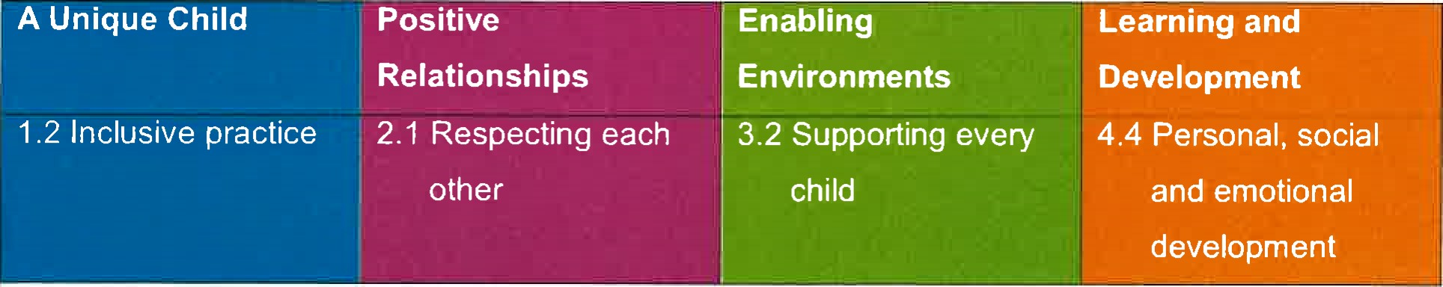
What it means to promote children's rights and entitlements to be 'strong, resilient and listened to'.
To be strong means to be:
secure in their foremost attachment relationships where they are loved and cared for, by at least one person who is able to offer consistent, positive and unconditional regard and who can be relied on; safe and valued as individuals in their families and in relationships beyond the family, such as day care or school ; self assured and form a positive sense of themselves — including all aspects of their identity and heritage; included equally and belong in early years settings and in community life; confident in abilities and proud of their achievements; progressing optimally in all aspects of their development and learning; to be part of a peer group in which to learn to negotiate, develop social skills and identity as global citizens, respecting the rights of others in a diverse world; and to participate and be able to represent themselves in aspects of service delivery that affects them as well as aspects of key decisions that affect their lives.
To be resilient means to:
be sure of their self worth and dignity; be able to be assertive and state their needs effectively; be able to overcome difficulties and problems; be positive in their outlook on life; be able to cope with challenge and change; have a sense of justice towards self and others; to develop a sense of responsibility towards self and others; and to be able to represent themselves and others in key decision making processes.
To be listened to means:
adults who are close to children recognise their need and right to express and communicate their thoughts, feelings and ideas; adults who are close to children are able to tune in to their verbal, sign and body language in order to understand and interpret what is being expressed and communicated; adults who are close to children are able to respond appropriately and, when required, act upon their understanding of what children express and communicate ; and
Adults respect children's rights and facilitate children's participation and representation

in imaginative and child centred ways in all aspects of core services.
This policy was adopted at a meeting of Gorran Preschool name of setting
Held on October 2019
Date to be reviewed October 2020
Signed on behalf of the management
Committee
Name of signatory
Michelle Beard
Role of signatory (e.g chair person)
Preschool Leader/Nominated Person

